 | 18.1.4 Editors - Graph Editor - Select Menu
Table of content
Graph Editor - Select Menu 1
All 1
None 1
Inverse 2
Box Select 2
Box Select(Axis Range) 2
Last Operator Box Select 2
Axis Range 2
Include Handles 2
Tweak 2
Mode 2
Circle Select 2
Lasso Select 3
Columns on Selected Keys 3
Columns on Current Frame 3
Columns on Selected Markers 3
Between Selected Markers 3
Last Operator Select All 3
Mode 3
Linked 3
Before current Frame 3
After current Frame 3
Last Operator Select Left/Right 3
Mode 3
Extend Select 3
More 4
Less 4

Graph Editor - Select Menu

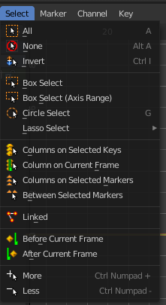
The Select menu contains various tools to select elements.
The content is the same in all modes. With one exception. Grease Pencil mode is missing the More / Less menu items.

All
Select everything.

None
Select nothing.

Inverse
Invert the current selection.

Box Select
Box select enters the Border Select mode. Select elements by dragging a rectangle around it. Just what's inside of the rectangle gets selected then.
It adds to selection by default. To subtract from selection hold down Shift key.
The selection gets applied when you release the mouse. You leave the mode automatically when you release the mouse.

Box Select(Axis Range)
Box select enters the Border Select mode. Select elements by dragging a rectangle around it. And what's inside the horizontal range of the rectangle gets selected then. Even when the keyframes are outside of the rectangle.
It adds to selection by default. To subtract from selection hold down Shift key.
The selection gets applied when you release the mouse. You leave the mode automatically when you release the mouse.

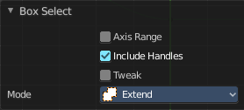
Last Operator Box Select

Axis Range
What's inside the horizontal range of the rectangle gets selected.

Include Handles
Also select the curve handles.

Tweak
Operator has been activated using a tweak event.

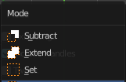
Mode
The selection mode to use.

Circle Select
Circle select enters the Circle Select mode. This is a special select mode where you can select elements by moving with the mouse over it. It adds to selection by default.
To subtract from selection hold down Shift key. To exit the Circle select click with the right mouse button.
The pencil radius of the circle select tool can be adjusted with the scroll wheel.

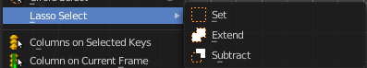
Lasso Select
A sub menu with the available lasso select modes.

Columns on Selected Keys
Select the keyframes in the columns of the currently selected keyframe.

Columns on Current Frame
Select the keyframes in the columns of the current frame.

Columns on Selected Markers
Select the keyframes in the columns of the selected markers.

Between Selected Markers
Select the keyframes between the selected markers. You need to have markers in the view for this feature.

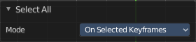
Last Operator Select All

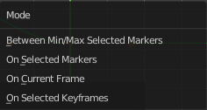
Mode
The selection mode to use.

Linked
Select all UV vertices linked to the active UV map. The previous selection gets cleared.

Before current Frame
Select the keyframes before the current frame.

After current Frame
Select the keyframes after the current frame.

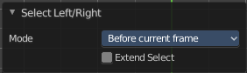
Last Operator Select Left/Right

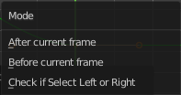
Mode
The selection mode to use.

Extend Select
Extend the current selection.

More
Grow the selection.

Less
Shrink the selection.

